Nuvoton Quad-Copter User Manual

Product No. | M4 Quad-Copter Solution
Function | User Manual

File Information
Name | Nuvoton Quad-Copter User Manual.pdf
Project | M4 Application
Function | User Guide
Purpose
Author | TZU-LAN SHEN
Revision History
Revision | Date | Comments
1.0 | 15/1/9 | Original Plan
1.1 | 15/4/1 | - Add SSV RC and Common Receiver Connection Diagram  - Add anti-USA (Mode 3) description
1.2 | 15/4/13 | - Add AUX1/AUX2 description  - Add V1.3 pcb image
1.3 | 15/4/17 | Add copter/joystick match process
1.4 | 15/5/14 | Add RC channels range and update pcb picture v1.4

Release Note:
Revision 1.0 | (1st Draft Version)
Revision 1.1 | RC feature update and anti-USA support
Revision 1.2  Revision 1.3  Revision 1.4 | Add AUX1/AUX2 description  Match process  Add RC channels range

- Nuvoton Fly Control Board
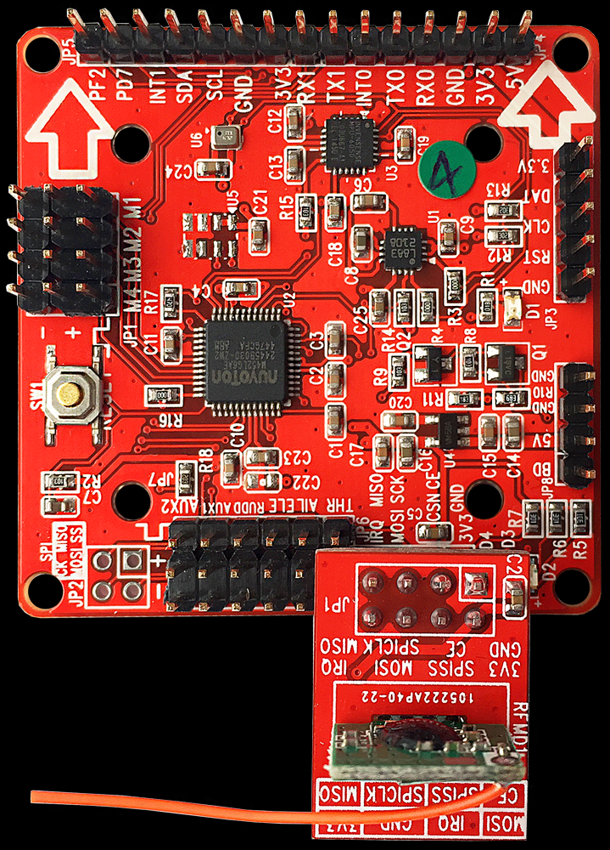
- Nuvoton cortex M4, 72 MHz
- 10 DOF sensor fusion.
- 400Hz AHRS refresh rate.
- Support 400Hz high-speed ESC .
- Support Quad-X frame copter.
- Support UART-BT tuning.
- Support user PID control.
- Support I2C sensor extension port.
- Support battery detects.
- Support radio R.C control. (option)
- Connection Diagram

Sensor Extension
UARTB.T
M0
ESC 0
ESC 1
ESC 2
ESC 3
M1
M2
M3
BD
5V
3SBattery
Front
Battery Detect
Power In
Reset
Armed
Mag mode
Headfree mode

Upgrade link

Common
Receiver
SSV
RF Module

- SSV RF Connection

SSV RF Module
MISO
SCK
CE
GND

IRQ
MOSI
CS
3V3

- COMMON RC Receiver Connection
AUX2 AUX1 RUD ELE AIL THR

Signal
+
-

Common RC Receiver

- AUX1 and AUX2 of COMMON RC Receiver

PWM | <1500 | >=1500
AUX1 | Altitude Hold Mode OFF | Altitude Hold Mode ON
Altitude Hold Mode OFF:
Copter up and down controlled directly by user throttle.
Altitude Hold Mode ON:
Copter keeps it current altitude and user use throttle stick to adjust the altitude higher and lower.

PWM | <1333 | 1333 ~ 1666 | >1666
AUX2 | No MAG Mode | MAG Mode | HeadFree Mode

No MAG Mode:
MAG disable, the direction reference GYRO only. If your fly field has potential magnetic interference, use Normal Mode will be a good idea.
MAG Mode:
In MAG mode, direction will reference MAG which makes copter has a steady direction without GYRO drift.
HeadFree Mode:
When HeadFree mode enabled, copter keeps current direction as it’s front direction(HeadFree direction). Copter head is no longer the forward direction, and it will mode front by the Headfree direction instead.

- Frame Diagram

Front

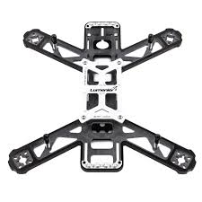
M3
M2
M0
M1
Copter Frame

Front

Fly Control Board

- LED Status
There are 3 on board led. Red for arm state and gyro calibration, green for mag state and mag calibration and orange for Head-Free state. The arm state also implied the default stabilize mode.

Red
Copter armed, and mode stabilized mode
Gyro calibration
Copter dis-armed

Green
Mag mode on
Mag calibration
Mag mode off

Orange
Head-Free mode on
Head-Free mode off

- Remote Controller (USA, mode2)

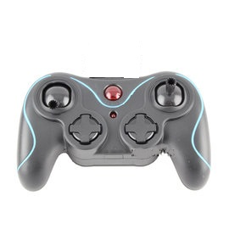
Left

Rotate
Right

LB, Alt-hold switch

RB, Mode switch

Throttle +

Throttle -

Rotate
Left

Forward

Backward

Right

On/Off

Control Bias Tuning

Throttle +

Throttle -

Rotate
Left

Rotate
Right

Forward

Left

Backward

Right

- Remote Controller (Anti-USA, mode3)

Left

Forward

Backward

Right

Rotate
Right

Throttle +

Throttle -

Rotate
Left

LB, Alt-hold switch

RB, Mode switch

On/Off

Control Bias Tuning

Throttle +

Throttle -

Rotate
Left

Rotate
Right

Left

Forward

Backward

Right

- Remote Controller LED
There are 2 LED in front of remote controller. Red for radio connection to copter, arm and during calibration state, green for altitude hold state.

*Red led will blinking 2 seconds when successfully connect to copter. If there is no led blinking, check the controller battery and the power supply of copter.

Radio connect to copter, armed, and mode stabilized
Gyro calibration
Copter dis-armed or controller disconnect to copter
Red

Altitude hold on
Altitude hold off

Green

- Copter Arm
Move throttle stick lower-right (min throttle and rotate right) to start the motor. The red led will start blinking (gyro calibration), and turned on when copter armed ready.
*Please turn off altitude hold mode before arming copter, copter can’t be armed in altitude mode for safe reason.
For USA (Mode 2)
For Anti-USA (Mode 3)
- Copter Disarm
Move throttle stick lower-left (min throttle and rotate left) to stop the motor. The red led will turned off when copter dis-armed.
For USA (Mode 2)
For Anti-USA (Mode 3)

- Copter Expert Mode
The expert mode provides an aggressive control for user. Copter becomes more sensitive to response user control. Move left stick lower-right and move right stick to lower-left at the same time. The red led will start blinking and the copter is now in expert mode when led on steady. You can switch back to standard mode by first dis-arm copter than arm the copter again by normal arm process.

- Copter and Joystick Match Process(SSV RC)
For the SSV remote control system, user has to make a copter and a joystick pair for the control relationship. The joystick can control only the paired copter. Nuvoton copter supports max 8 copters can play at the same time. Each copter/joystick pair has it’s specific communication channel. The match process between copter and joystick as below:
  - Power on your copter and joystick
  - The copter green led (MAG enable) on at beginning
  - The copter green led (MAG enable) off and joystick makes a beep sound – match done

*If no match between copter and joystick over 10 seconds, re-power on both copter and joystick again.

- SSV RC Remote Controller Notice
The suggestion remote control range is less than 50 meter diameter, the distance could be even shorter if there are obstacles between copter and joystick. The other 2.4G signal (Wi-Fi, other RC ..) can also interfere the remote control. If you feel the copter is out of control once a while, find another place to fly is a good idea.

- Common RC Remote Controller Notice
Nuvoton fly controller has define the necessary channel range for common RC control. User should follow the definition and make sure your RC controller satisfy the condition.
Channel | Min | Mid | Max | Type | AltHold | Mode
THR | <1090 | - | >1920 | Continuous
ROLL | ~1100 | - | ~1900 | Continuous
PITCH | ~1100 | - | ~1900 | Continuous
YAW | <1090 | - | >1920 | Continuous
AUX1 | <1500 | - | >1500 | 2 level | V
AUX2 | <1333 | ~1500 | >1666 | 3 level |  | V

- Copter Ready To Fly Suit Suggestion
Parts | Quantity | Specification | Description
Copter Frame | 1 | QAV250 | The full carbon fiber frame is better and motor center to center distance is about 250 mm
ESC | 4 | 12A | EMAX 12A ESC
Motor | 4 | 1806 | EMAX 1806/2280KV BLDC
Propeller | 4 | 6045 | Plastic propeller (No fiber)
Battery | 1 | 2200mah/30C | FULLYMAX Ki-Po 30C/Burst60C  11.1V(3S)/XT60 Connector
Battery Charger | 1 | Fast charger for 3S Li-Po | iMax B6
RC Controller | *1 | 6 CH | Devo7
RC Reciver | *1 | 6 CH | RX701
Low Battery Detector | #1 | Detect 3S Li-  Po | Beep when battery low

* Optional, If you don’t have SSV 2.4G RC, you can by common RC TX/RX.
# Optional, you need a battery charger to charge your Li-Po battery for safty.

